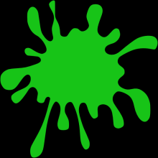 SLIME LAB

Introduction: Slime is a substance that has some properties of a solid, and some properties of a liquid. These types of substances are called colloids. Popular colloids include milk, mayonnaise, Jello, and even whipped cream. There are many different types of slime and many different recipes. They also have different names. To make Oobleck, mix water and cornstarch together. We will be making Glurch, or Flubber, which is made with Borax, glue and water-and I call Slime!

Materials
15 mL water 3 Small baggies
25 mL white glue Food coloring
10 mL Borax Solution 25mL of PVA (Polyvinyl Alcohol)
3 Wooden Splints

Procedure: Check off your procedures as you complete each step.
Part 1-Glue and Borax Slime

1. Make sure all materials are clean and dry..
2. Measure 25mL glue into the plastic cup labeled GLUE—up to the marked line labeled glue.
3. Measure 15mL water in a 25 mL graduated cylinder labeled H₂O.
4. Add the water to the glue and mix with a wooden stick.
5. Get 2 drops of food coloring from Mrs McKenzie.
6. Stir the Slime with the wooden stick.
7. Record observations in row 1 of your data table.
8. Add slime to the baggie labeled GLUE SLIME.
9. Seal bag (double check, make sure it is closed).

Procedure: Check off your procedures as you complete each step.
Part 2-PVA Slime

1. Pour 25 mL of PVA (Polyvinyl Alcohol) into the CLEAN Plastic Cup Labeled PVA-up to the marked line labeled PVA.
2. Get 2 drops of food coloring from Mrs McKenzie.
3.Measure 5 mL borax solution into a 10 ml graduated cylinder labeled BORAX.
4. Add the borax to the PVA Cup and stir with a wooden stick until mostly combined.
5. Mix until there is no liquid.
6. Record observations in row 2 of your data table.
7. Add slime to the baggie labeled PVA SLIME.
8. Seal bag (double check, make sure it is closed).

Procedure: Check off your procedures as you complete each step.
Part 3- Corn Starch Slime
1.
2.
3.
4.

Procedure: Check off your procedures as you complete each step.
Part 4- CLEAN UP TIME

WHEN YOU HAVE MADE YOUR SLIME….
1.CLEAN UP EVERYTHING!!!!
2.All Plastic cups and Wooden Sticks can go in the trash.
3.Clean, rinse out, and dry all graduated cylinders.
4.Take a sponge and wipe down your table.
5.Any paper towels need to go into the trash.

When you are done cleaning your desk/station – raise your hand to get a stamp

Observations
Observations – use all of your senses but TASTE!!
Part 1- Glue

Part 2- PVA

Part 3- Corn Starch

Analysis and Conclusion
- Oobleck is made by combining: Solid, Liquid, or gas?
- Water
- Borax
- Glue
- Food Coloring

- Press your slime from Part 2 (PVA), into a ball. Let it sit on your table for a couple of minutes and observe. What do you see?

- Put a small object like a paperclip on the slime from part 3 (Corn Starch). Let it sit for a while. What happens?

- Overall, do the 3 slimes behave like a solid, liquid, or gas? Explain WHY you think that.

- Do you think your slime is an element, compound, or mixture?
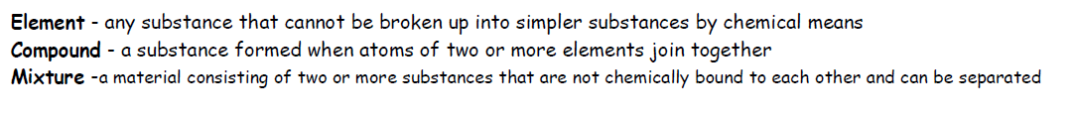
- 5 Sentence Conclusion:

