Name:________________________________________
Distance-Time Graph
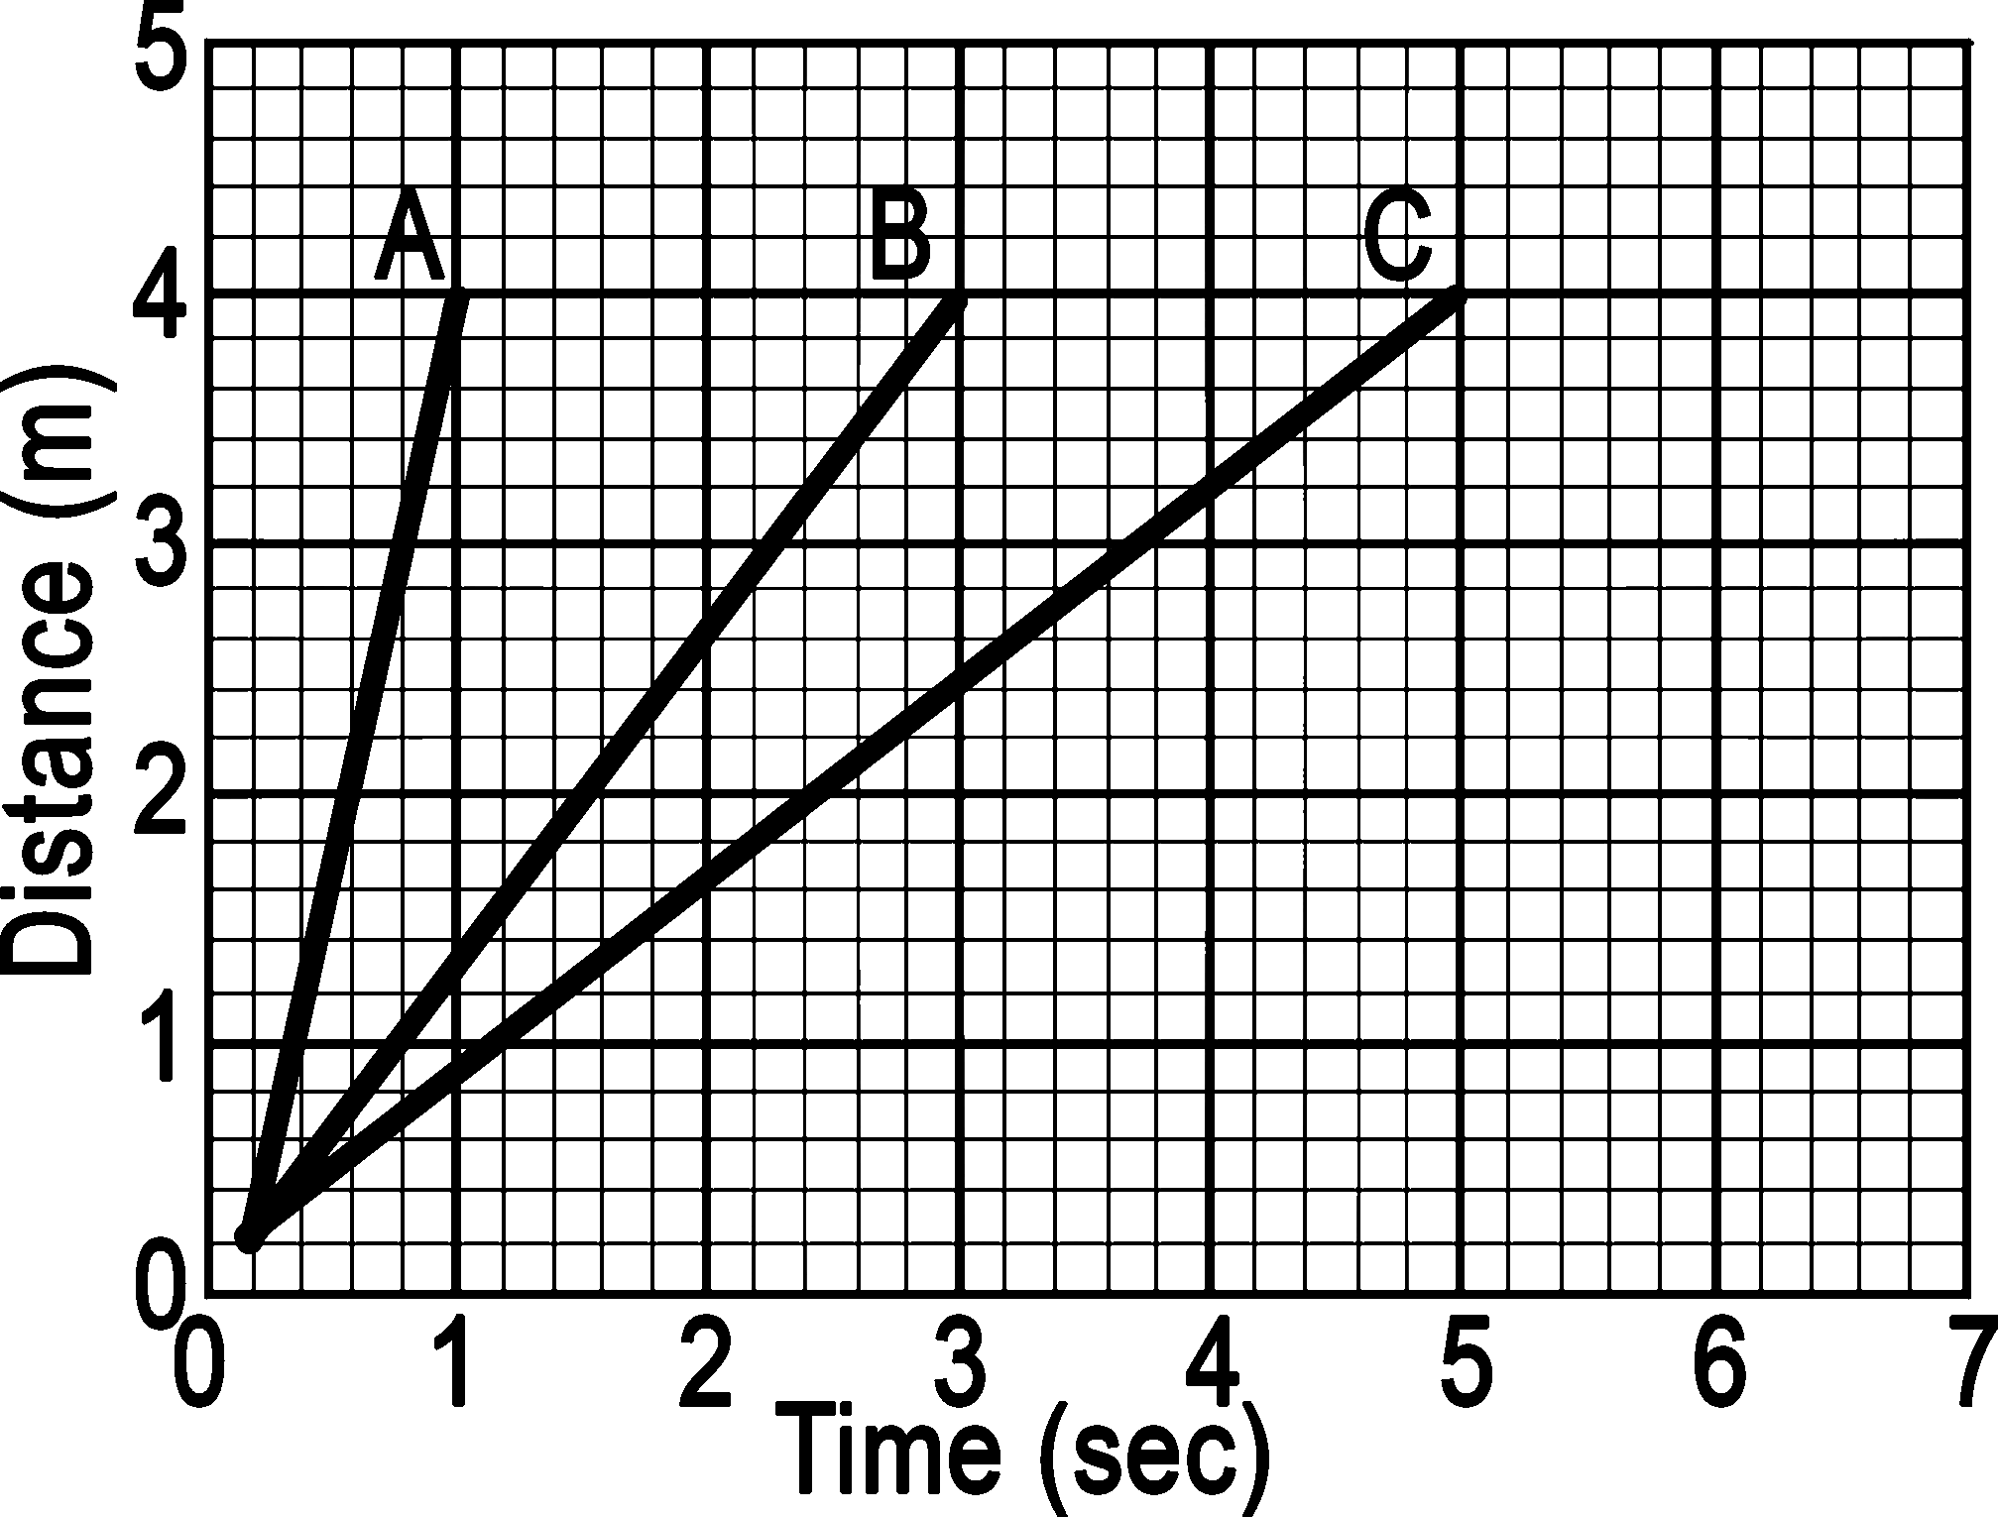
Directions: Find the Speed (Slope) of each of the 3 lines. Be sure to SHOW ALL WORK for full credit.
A:

B:

C:

